Smartphone Usage, Digital Addiction &
Well-Being Analytics

Introduction
Smartphone usage has become a central part of daily life, and with it comes growing concern around digital addiction and its effects on sleep, stress, academic performance, and overall well-being. Usage behavior is shaped by a wide range of interacting factors — daily screen time, social media and gaming hours, notification volume, sleep patterns, stress level, and academic or work impact — making it difficult to identify which behaviors most strongly predict addictive usage patterns. The core objective of this project is to analyze these attributes together to uncover patterns and determine which factors and user groups are most strongly associated with smartphone addiction.
Without a consolidated view, product teams, researchers, and digital well-being programs may overlook high-risk user segments, misjudge which behaviors drive addiction, and miss opportunities for early intervention such as usage nudges, screen-time limits, or well-being coaching. The proposed solution is an interactive analytical dashboard that combines demographic, behavioral, and lifestyle information into a single view, enabling stakeholders to compare addiction patterns across age group, gender, stress level, and academic impact, identify high-risk segments, and gain clear, actionable insights to support healthier digital habits.

Scenarios

Scenario 1: Maya Chen — Head of Digital Well-Being Product
Maya Chen leads the digital well-being initiative for a consumer technology company. She wants to understand how daily screen time, social media hours, and notification volume relate to addiction level across the user base, so she can identify which segments carry the greatest risk of unhealthy usage.
Her goal is to reduce the share of users in the Severe addiction band, prioritize feature investment (such as usage limits and mindful-notification tools), and design targeted well-being nudges for high-risk user groups. She relies on interactive dashboards to support quarterly product planning and leadership reporting.

Scenario 2: Daniel — User Behavior Analyst
Daniel is responsible for monitoring behavioral and lifestyle risk factors across the user population. He wants to analyze how gaming hours, work/study hours, sleep hours, and stress level influence the likelihood of addicted usage.
His objective is to identify early behavioral warning signs, flag user segments at elevated lifestyle-driven risk, and support intervention programs such as sleep-hygiene reminders and stress-aware usage coaching.

Scenario 3: Dr. Priya Nair — Digital Health Researcher
Dr. Priya Nair studies the relationship between usage intensity metrics — app opens per day, notifications per day, weekend screen time, and academic/work impact — and addiction outcomes. She analyzes how these measurements vary across age groups and gender.
Her aim is to identify the strongest behavioral predictors of smartphone addiction, uncover patterns across user sub-groups, and provide evidence-based recommendations for digital well-being thresholds and intervention design.

Technical Architecture
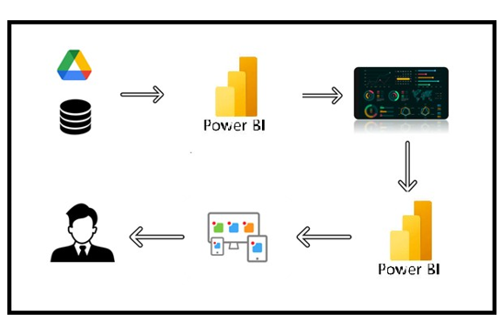

Project Flow
1. Problem Definition & Data Collection

Identify the business problem

Define project objectives

Collect the dataset

Understand dataset structure

2. Database Setup & SQL Analysis
- Create SQL Database and Load the Dataset

Perform SQL operations

3. Power BI Data Preparation

Connect SQL database with Power BI

Clean data using Power Query

4. Data Visualization
• KPI Creations and Explore factors affecting KPIs
• Creating Visualizations
  - Decomposition Tree
  - Key Influencer
  - Business Question with Visualizations

5. Dashboard Development

Design dashboard

6. Report Development

Report 1

Report 2

7. Performance Testing

Amount of data rendered to the database

Utilization of data filters

number of calculation fields

number of visualizations/graphs
8. Project Demonstration & Documentation
- Record explanation video for project end-to-end solution
- Project Documentation – Step-by-step project development procedure

Milestone 1: Problem Definition & Data Collection
In this milestone, we will begin by understanding and clearly defining the business problem that the project aims to solve. We will identify the project objectives, key requirements, and important business questions that need to be answered through data analysis. We will then collect the relevant dataset from appropriate sources and review its structure, including the available tables, columns, data types, records, and key attributes. Finally, we will assess the collected data to ensure it contains the information required to address the defined problem and achieve the project objectives.

Activity 1: Identify Business Problem
The organization needs to understand why 5,308 of its 7,500 users (70.77%) are classified as addicted to smartphone usage, and which factors — screen-time behavior, lifestyle habits, stress, or demographic characteristics — most strongly correspond with that classification. Without this understanding, product and research teams cannot prioritize well-being feature investment or design targeted digital-health interventions.

Activity 2: Define Project Objectives
- Quantify overall and segment-level addiction prevalence across gender, age group, and stress level.
- Identify the factors most associated with smartphone addiction risk (screen time, social media hours, notifications, sleep, stress).
- Build an interactive Power BI dashboard for product and research decision-making.
- Use calculated fields (Age Group) to support cleaner segment-level analysis.
- Deliver clear, actionable insight to support digital well-being interventions and healthier usage habits.

Activity 3: Collect Dataset
The dataset used for this project is Smartphone_Usage.csv, containing 7,500 user records across 16 attributes, covering demographics, daily usage behavior, notification and app-open volume, lifestyle habits, and addiction status.
Dataset : Smartphone_Usage.csv

Activity 4: Understand Dataset Structure — Column Description
Column | Description
transaction_id | Unique identifier assigned to each usage record.
user_id | Unique identifier assigned to each user.
age | Age of the user in years.
gender | Gender of the user (Male / Female / Other).
daily_screen_time_hours | Average daily smartphone screen time, in hours.
social_media_hours | Average daily hours spent on social media apps.
gaming_hours | Average daily hours spent on gaming apps.
work_study_hours | Average daily hours of phone use for work or study.
sleep_hours | Average nightly sleep duration, in hours.
notifications_per_day | Average number of notifications received per day.
app_opens_per_day | Average number of app opens per day.
weekend_screen_time | Average weekend screen time, in hours.
stress_level | Self-reported stress level (Low / Medium / High).
academic_work_impact | Whether usage negatively impacts academic/work performance (Yes / No).
addiction_level | Categorized addiction severity (None, Mild, Moderate, Severe).
addicted_label | Whether the user is classified as addicted (1 / 0) — target variable.

Milestone 2: Database Setup & SQL Analysis
In this milestone, learners work with the setting up databases and developing the SQL skills needed to work with structured data. Learners will create and manage database objects, load and organize data, and write SQL queries to retrieve, filter, transform, and analyze information. The milestone builds a strong foundation for efficient data analysis and prepares learners to work with real-world datasets and business problems.

Activity 1: Create SQL Database and Load the Dataset
A relational database, smartphone_usage, was created in MySQL Workbench to host the smartphone usage dataset in a structured, queryable form. The Smartphone_Usage.csv file was imported into a single table, smartphone_usage, with appropriate data types assigned: integer/decimal types for numeric measurements and counts, and varchar for categorical fields such as gender, stress_level, and addiction_level. The import completed successfully, loading all 7,500 records.
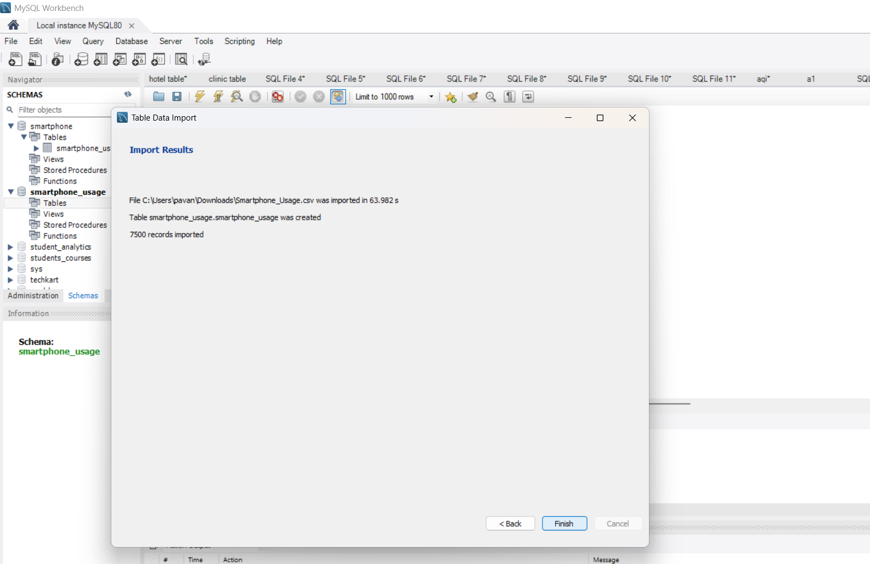

Explanation video : Dataloading.mp4

Activity 2: Perform SQL Operations
Exploratory SQL queries were used to validate data quality and generate baseline metrics before moving to Power BI.
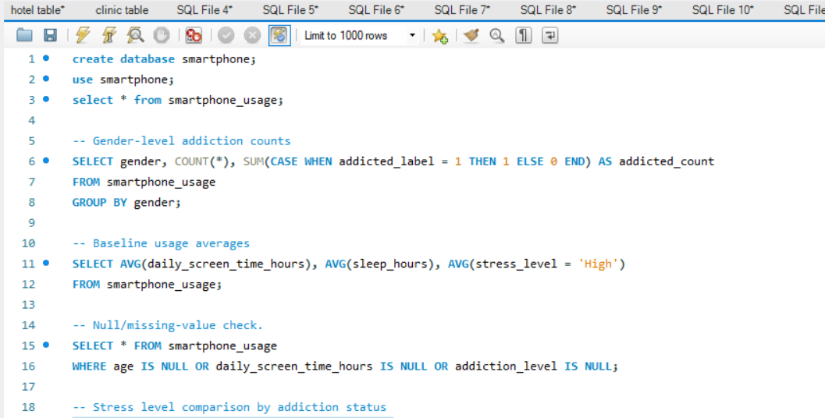
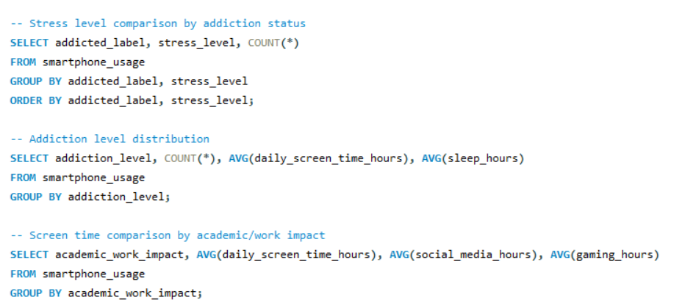
- Creating Data Base
create database smartphone;
use smartphone;
select * from smartphone_usage;
- Gender-level addiction counts
SELECT gender, COUNT(*), SUM(CASE WHEN addicted_label = 1 THEN 1 ELSE 0 END) AS addicted_count
FROM smartphone_usage
GROUP BY gender;
- Baseline usage averages
SELECT AVG(daily_screen_time_hours), AVG(sleep_hours), AVG(stress_level = 'High')
FROM smartphone_usage;
- Null/missing-value check.
SELECT * FROM smartphone_usage
WHERE age IS NULL OR daily_screen_time_hours IS NULL OR addiction_level IS NULL;
- Stress level comparison by addiction status
SELECT addicted_label, stress_level, COUNT(*)
FROM smartphone_usage
GROUP BY addicted_label, stress_level
ORDER BY addicted_label, stress_level;
- Addiction level distribution
SELECT addiction_level, COUNT(*), AVG(daily_screen_time_hours), AVG(sleep_hours)
FROM smartphone_usage
GROUP BY addiction_level;
- Screen time comparison by academic/work impact
SELECT academic_work_impact, AVG(daily_screen_time_hours), AVG(social_media_hours), AVG(gaming_hours)
FROM smartphone_usage
GROUP BY academic_work_impact;
These queries confirmed the dataset was complete and consistent, and produced early evidence that addiction level varies meaningfully by stress level and screen-time intensity — a pattern that was carried forward into the Power BI model.

Milestone 3: Power BI Data Preparation
In this milestone, we will connect the SQL database with Power BI and import the required data for analysis. We will then use Power Query to clean and transform the data by handling missing or duplicate values, correcting data types, renaming columns, removing unnecessary fields, and applying the required transformations. This process will ensure that the data is accurate, consistent, and properly prepared for data modeling, analysis, and visualization in Power BI.

Activity 1: Connect SQL Database with Power BI
Power BI Desktop was connected to the MySQL database using the built-in database connector (Get Data → MySQL Database), importing the smartphone_usage table directly into the Power Query Editor for transformation.
Explanation video : sql to powerbi.mp4

Activity 2: Clean Data Using Power Query
Data cleaning and shaping was performed in Power Query to prepare the dataset for visualization, including:
- Verifying and correcting column data types (e.g., addicted_label as whole number; screen-time and hours fields as decimal).
- Trimming and standardizing text fields such as gender, stress_level, academic_work_impact, and addiction_level.
- Checking for and confirming the absence of duplicate user_id / transaction_id values.
- Reviewing column distributions to confirm no irrelevant or erroneous data.
- Creating a calculated column — Age Group — to support categorical, band-level analysis.
Since the dataset was already clean and well-structured, minimal transformation was required before moving to data modelling and visualization.
Explanation video : power query.mp4

Milestone 4: Data Visualization

In this milestone, we will create meaningful and interactive visualizations in Power BI to analyze the prepared data and identify key business insights. We will create KPIs and explore the factors affecting their performance using relevant dimensions and measures. We will develop appropriate charts and visual elements to represent trends, comparisons, patterns, and relationships in the data. Finally, we will customize and interpret the visualizations to communicate insights clearly and support data-driven decision-making.

Activity 1: KPI Creation and Explore Factors Affecting KPIs
5,308  Users Addicted | 7,500  Total Users Analyzed | 26.57  Average Age | 7.50 hrs  Avg Daily Screen Time
3.27 hrs  Avg Social Media Hours | 2.01 hrs  Avg Gaming Hours | 6.74 hrs  Avg Sleep Hours | 134.26  Avg Notifications / Day
97.83  Avg App Opens / Day | 9.24 hrs  Avg Weekend Screen Time | 3.24 hrs  Avg Work / Study Hours

Exploration of these KPIs against underlying dimensions revealed several consistent patterns:
- Users Addicted – 5,308: Addicted usage is present in approximately 70.77% of the 7,500 users analyzed.
- Total Users Analyzed – 7,500: The dashboard covers a substantial user population, providing a strong base for behavioral and lifestyle analysis.
- Average Age – 26.57 years: The user population is centered around the young-adult demographic, with 20–29 the largest age band.
- Average Daily Screen Time – 7.50 hours: A high baseline of daily usage across the population.
- Average Sleep Hours – 6.74: Users average slightly under the commonly recommended 7–9 hours, an important well-being indicator.
- Average Notifications per Day – 134.26: A high notification load, relevant to compulsive-checking behavior.
- Average Weekend Screen Time – 9.24 hours: Weekend usage runs notably higher than the weekday/overall daily average.

Activity 2: Creating Visualization

In this activity, we will create different data visualizations in Power BI to represent the data clearly and uncover meaningful insights. We will select appropriate chart types based on the data and analysis requirements, configure relevant fields and measures, and customize titles, labels, legends, and other formatting options. We will then analyze the visualizations to identify trends, comparisons, patterns, and relationships within the data.

2.1 : Decomposition Tree

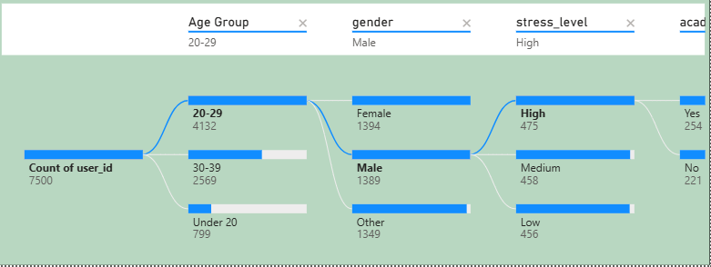
The decomposition tree shows that among the platform's 7,500 users, the 20–29 age group is the dominant segment (4,132 users, 55%), with gender split almost evenly within it (Female 1,394, Male 1,389, Other 1,349). Drilling into 20–29 males, stress level is also fairly balanced across High, Medium, and Low (475, 458, 456), so no single stress band stands out by volume. However, among the High-stress users in this segment, 254 (53.5%) report a Yes to academic/work impact versus 221 (46.5%) No — a noticeably higher share than the near 50/50 split seen across the full user base.

- Age dominates segment size: 20–29 year-olds make up 55% of all users (4,132 of 7,500), far outweighing 30–39 (34%) and Under 20 (11%).
- Gender is evenly distributed within 20–29: Female (1,394), Male (1,389), and Other (1,349) are nearly identical, so gender alone isn't a differentiating factor at this age.
- Stress level is balanced among 20–29 males: High (475), Medium (458), and Low (456) show only a slight lean toward High stress, not a sharp skew.
- Academic/work impact rises with high stress: Among High-stress, 20–29 male users, 53.5% (254) report a negative academic/work impact vs. 46.5% (221) who don't — a clear shift from the roughly even 50/50 split seen across the overall user base.
- Compounding risk factor: No single dimension (age, gender, or stress) alone explains the impact rate — it's the intersection of 20–29 + Male + High stress that produces the strongest signal.
2.2: Key Influencer
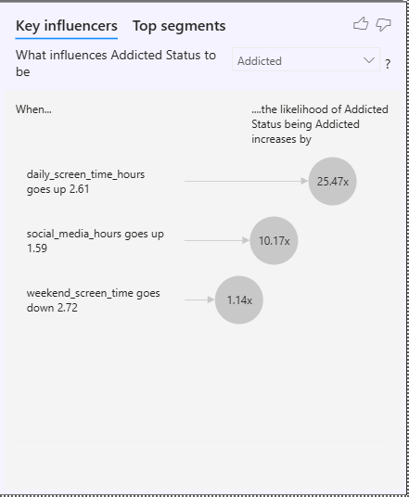
The Key Influencers visual identifies the strongest drivers of Addicted status in the dataset. Daily screen time is by far the dominant factor — a 2.61-hour increase raises the likelihood of being classified as Addicted by 25.47x, making it the single most powerful predictor in the model. Social media hours is the second strongest influencer, with a 1.59-hour increase associated with a 10.17x higher likelihood of addiction. Interestingly, a decrease in weekend screen time (down 2.72 hours) is also linked to a modest 1.14x increase in addiction likelihood, a counter-intuitive result that likely reflects a secondary correlation rather than a direct cause.
- Daily screen time is the top driver: A 2.61-hour increase raises the likelihood of Addicted status by 25.47x — by far the strongest influencer identified.
- Social media hours is the second-strongest factor: A 1.59-hour increase is associated with a 10.17x increase in addiction likelihood.
- Weekend screen time shows a weaker, counter-intuitive link: A decrease of 2.72 hours corresponds to only a 1.14x increase in likelihood — a much smaller effect, and directionally different from daily/social media usage.
- Magnitude gap is significant: Daily screen time's influence (25.47x) is roughly 2.5x stronger than social media hours (10.17x) and over 20x stronger than the weekend screen time signal (1.14x).
- Behavioral pattern, not demographic: All three influencers are usage-behavior metrics rather than age, gender, or stress — suggesting addiction risk is driven primarily by how much someone uses their phone daily, not who they are.
2.3. Visualization Analysis & Insights :
1. Users by Addiction Level
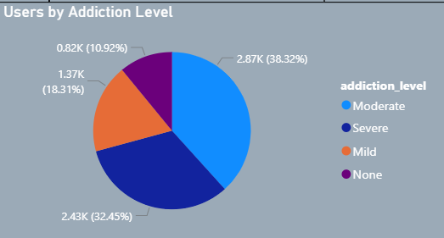
The chart shows the overall addiction level distribution across 7,500 users. Moderate addiction is the largest group at 2.87K users (38.32%), followed by Severe at 2.43K (32.45%), Mild at 1.37K (18.31%), and None at 0.82K (10.92%). This highlights that nearly 71% of the user population falls into the Moderate or Severe addiction bands, indicating that heavy or compulsive smartphone usage is the norm rather than the exception in this dataset.
2. Average Daily Screen Time by Gender
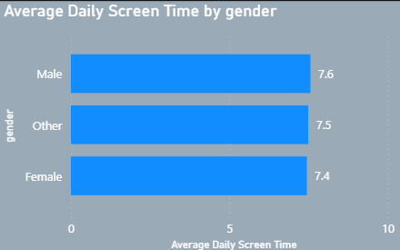
The chart shows average daily screen time broken down by gender. Male users average 7.6 hours, Other users average 7.5 hours, and Female users average 7.4 hours. The narrow spread across groups indicates that daily screen time is fairly consistent regardless of gender, suggesting gender is not a strong differentiator of overall usage volume.

3. Average Sleep Hours by Addiction Level
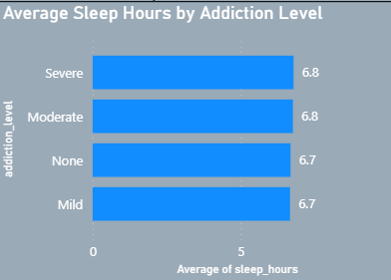
The chart shows average sleep hours across the four addiction levels. Severe and Moderate users average 6.8 hours of sleep, while Mild and None users average 6.7 hours — a difference of only 0.1 hours. This near-flat pattern suggests that sleep duration alone is a weak standalone indicator of addiction severity in this population.
4. Weekend Screen Time: Addicted vs Not Addicted
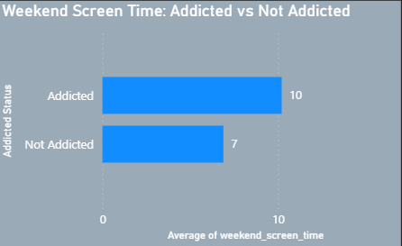
The chart compares average weekend screen time between addicted and non-addicted users. Addicted users average 10 hours of weekend screen time, compared to 7 hours for non-addicted users. This 3-hour gap is one of the clearest behavioral distinctions in the dataset, showing that weekend usage intensity rises sharply for users classified as addicted.

5. Users by Age Group
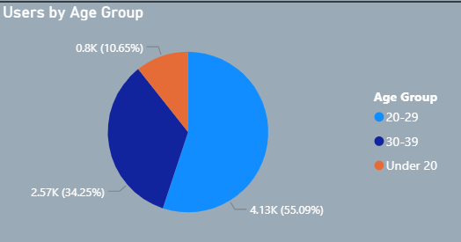
The chart shows the distribution of users across three age bands. The 20–29 age group is the largest at 4.13K users (55.09%), followed by 30–39 at 2.57K (34.25%) and Under 20 at 0.8K (10.65%). This confirms that the user base skews heavily toward young adults, with over half of all users falling in the 20–29 range.
6. Average Daily App Opens by Stress Level
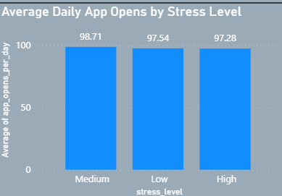
The chart shows average app opens per day segmented by stress level. Medium-stress users open apps most frequently at 98.71 times per day, followed closely by Low-stress users at 97.54 and High-stress users at 97.28. The near-identical values across all three groups suggest that stress level has minimal influence on how often users open their apps.
7. Gender by Addiction Level
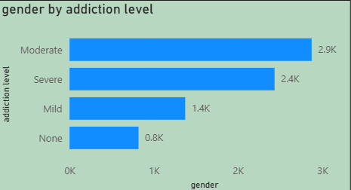
The chart shows the count of users across addiction levels combined across genders. Moderate addiction accounts for the highest count at 2.9K, followed by Severe at 2.4K, Mild at 1.4K, and None at 0.8K. This reinforces that the majority of the user base sits in the Moderate-to-Severe addiction range, consistent with the overall addiction level distribution.
8. Average Work/Study Hours by Academic Impact
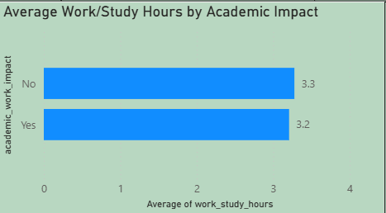
The chart compares average work/study hours between users who report academic or work impact and those who do not. Users reporting No impact average 3.3 hours, while users reporting Yes impact average 3.2 hours — a negligible difference. This indicates that the amount of time spent on work or study is not what drives academic/work impact; rather, it is likely the intensity or quality of phone usage during that time.
9. Weekend Screen Time by Addiction Level
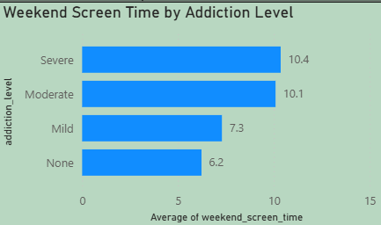
The chart shows average weekend screen time across the four addiction levels. Severe users average 10.4 hours and Moderate users average 10.1 hours, compared to just 7.3 hours for Mild and 6.2 hours for None. This nearly 4-hour gap between the highest and lowest severity groups makes weekend screen time one of the strongest visual indicators of addiction severity.
10. Weekend Screen Time by Age Group
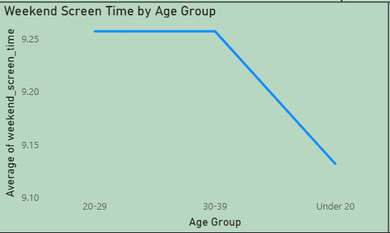
The chart tracks average weekend screen time across age groups. The 20–29 age group shows the highest average at approximately 9.25 hours, which declines through the 30–39 group and further for Under 20 users. This downward trend suggests that weekend usage intensity is highest among young adults and gradually decreases with age.
11. Users by Stress Level
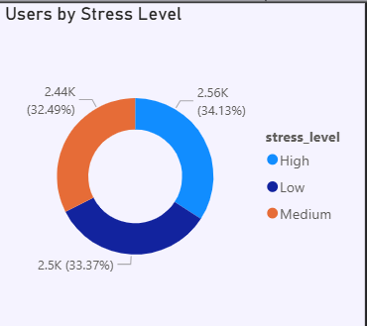
The chart shows the overall stress level distribution across all users. High stress accounts for 2.56K users (34.13%), Low stress for 2.5K (33.37%), and Medium stress for 2.44K (32.49%). The near-even three-way split indicates that stress is broadly distributed across the user base rather than concentrated in any single category.
12. Average Sleep Hours by Age Group
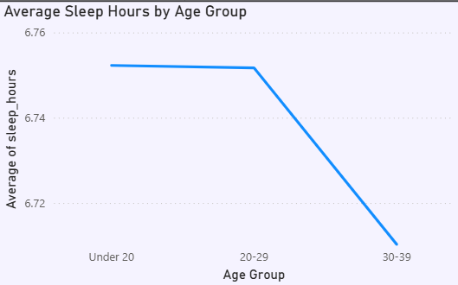
The chart tracks average sleep hours across age groups. Under 20 and 20–29 users average around 6.75 hours of sleep, while the 30–39 group drops slightly to 6.72 hours. The gradual decline suggests that sleep duration decreases marginally as users get older, though the overall difference remains small.
13. High vs Normal Screen Time Users
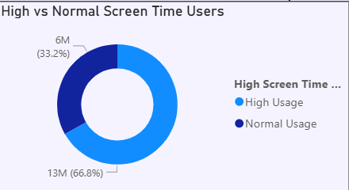
The chart shows the split between users with high versus normal screen time. High Usage accounts for 13M (66.8%) of the measured base, while Normal Usage accounts for 6M (33.2%). This indicates that roughly two out of every three users fall into the high-usage category, underscoring how widespread heavy smartphone engagement is across the population.
14. Average Social Media Usage by Addiction Level
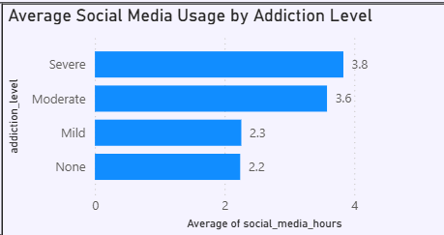
The chart shows average social media hours across addiction levels. Severe users average 3.8 hours and Moderate users average 3.6 hours, compared to 2.3 hours for Mild and 2.2 hours for None. This clear upward trend shows that social media usage rises consistently with addiction severity, making it one of the strongest behavioral markers of addicted status.

Milestone 5: Dashboard Development
In this stage, we will transform the prepared data into meaningful and interactive visualizations that make key information easier to understand. We will select suitable charts and visual elements, configure relevant fields and measures, and apply appropriate formatting to present the data clearly. The visualizations will help us identify trends, comparisons, patterns, and relationships, enabling us to derive useful insights from the data.

Activity 1: Design of Interactive Dashboard
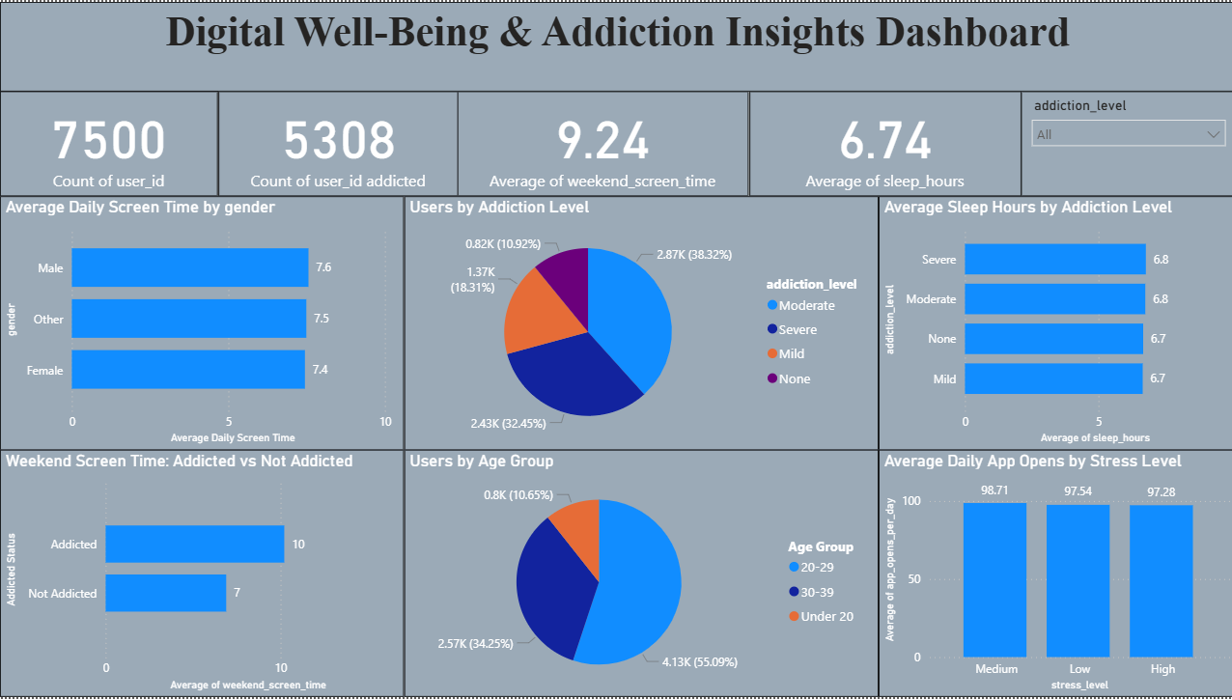
Insights:
- Addiction prevalence is high: 70.77% of the 7,500 users (5,308) are classified as addicted, with Moderate (38.32%) and Severe (32.45%) together making up over 70% of the population.
- Weekend screen time is the clearest addiction signal: Addicted users average 10 hrs on weekends vs. 7 hrs for non-addicted users — a 3-hour gap that stands out as the strongest behavioral differentiator on this dashboard.
- User base skews young: The 20–29 age group makes up 55% of all users (4.13K), more than double the 30–39 group (34%) and Under 20 (11%).
- Gender has minimal impact on usage: Daily screen time is nearly identical across Male (7.6 hrs), Other (7.5 hrs), and Female (7.4 hrs), showing gender isn't a differentiating factor.
- Sleep and stress show flat patterns: Sleep hours vary only marginally across addiction levels (6.7 -- 6.8 hrs), and app opens per day are nearly the same across stress levels (97.28 -- 98.71), suggesting neither is a strong standalone predictor.
Explanation Video :Dashboard.mp4

Milestone 6: Report Development
In this milestone, we will develop a comprehensive Power BI report by organizing the analyzed data, KPIs, visualizations, and key insights into meaningful report pages. We will apply appropriate layouts, formatting, filters, slicers, and navigation to make the report clear, interactive, and user-friendly. The final report will communicate important findings and provide actionable insights to support effective business decision-making.

Report 1:Digital Addiction & Screen Time Behavior Analysis
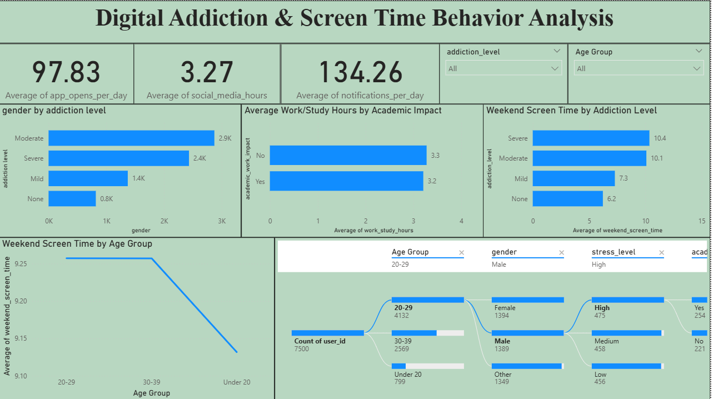

- Addiction levels skew toward higher severity: Moderate (2.9K) and Severe (2.4K) users far outnumber Mild (1.4K) and None (0.8K), confirming most users fall into the higher-risk addiction bands.
- Academic/work impact isn't driven by time spent: Users reporting No impact average 3.3 work/study hours vs. 3.2 hrs for Yes — an almost negligible difference, suggesting impact stems from usage quality/intensity rather than hours logged.
- Weekend screen time rises sharply with addiction severity: Severe (10.4 hrs) and Moderate (10.1 hrs) users show far higher weekend usage than Mild (7.3 hrs) and None (6.2 hrs) — a ~4-hour gap between the extremes.
- Weekend usage declines with age: The line chart shows weekend screen time peaking around 9.25 hrs for the 20–29 group and steadily dropping through 30–39 to Under 20, indicating younger adults are the heaviest weekend users.
- High engagement baseline overall: Users average 97.83 app opens and 134.26 notifications per day, alongside 3.27 hours of social media use — reflecting a generally high-frequency usage pattern across the board.
Explanation Video :Report 1.mp4

Report 2: Smartphone Addiction & Digital Well-Being Insights
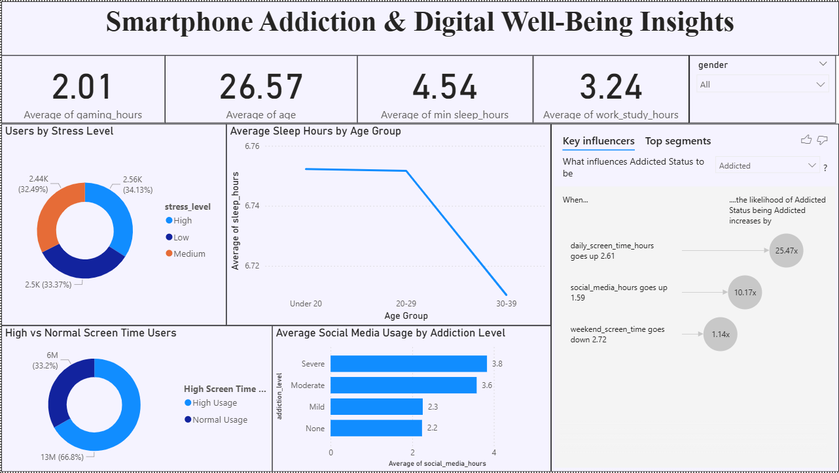

- Stress levels are broadly balanced: High stress (34.13%), Low stress (33.37%), and Medium stress (32.49%) are nearly evenly split, indicating stress is distributed uniformly across the user base rather than concentrated in one group.
- Sleep hours decline with age: Average sleep stays around 6.76 hrs for Under 20 and 20–29 users but drops to 6.72 hrs for the 30–39 group, suggesting a mild downward trend in sleep as users get older.
- High usage is the dominant pattern: 66.8% of users (13M) fall into the High Usage screen-time category vs. only 33.2% (6M) in Normal Usage — confirming that heavy smartphone engagement is the norm across this population.
- Social media usage rises sharply with addiction severity: Severe (3.8 hrs) and Moderate (3.6 hrs) users spend noticeably more time on social media than Mild (2.3 hrs) and None (2.2 hrs) users, making it a strong marker of addiction level.
- Daily screen time is the single biggest driver of addiction risk: The Key Influencers panel shows a 2.61-hr increase in daily screen time raises Addicted-status likelihood by 25.47x — far outweighing any other factor on this dashboard.

Explanation Video :Report 2 .mp4

Milestone 7: Performance Testing
Performance testing reviews the volume of data rendered from the database, the impact of data filters on responsiveness, and the complexity introduced by the number of visualizations and calculation fields, to ensure the dashboard operates efficiently.

Activity 1: Amount of Data Rendered to DB
The full smartphone_usage dataset — 7,500 user records across 16 columns — was loaded from the MySQL database into the Power BI data model without truncation or sampling, ensuring the dashboard reflects the complete user population.
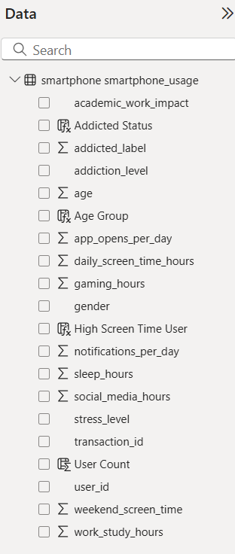

Activity 2: Utilization of Data Filters
Slicers and visual-level filters were applied throughout the dashboard to allow stakeholders to focus on specific user segments:
- Page 1 slicers: addiction_level.
- Page 2 slicers: addiction_level, Age Group.
- Page 3 slicers: gender.

Activity 3: Number of Calculation Fields
One DAX calculated column was created and implemented to derive a key segmentation field and support addiction risk analysis:
Age Group
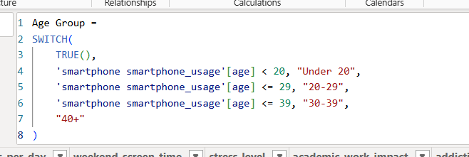

Addicted Status

High Screen Time User :

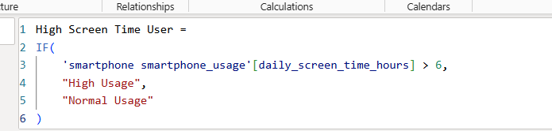

Activity 4: Number of Visualizations / Graphs
- Average Daily Screen Time by Gender
- Users by Addiction Level
- Average Sleep Hours by Addiction Level
- Weekend Screen Time: Addicted vs Not Addicted
- Users by Age Group
- Average Daily App Opens by Stress Level
- Gender by Addiction Level
- Average Work/Study Hours by Academic Impact
- Weekend Screen Time by Addiction Level
- Weekend Screen Time by Age Group
- User Segmentation
- Users by Stress Level
- Average Sleep Hours by Age Group
- High vs Normal Screen Time Users
- Average Social Media Usage by Addiction Level
- Key Influencers — What Influences Addicted Status

Milestone 8: Project Documentation & Demo
In this milestone, we will finalize the project by documenting the complete analysis workflow, key findings, and outcomes. We will organize the project deliverables and conduct a final demo to showcase the implementation, explain the approach.

Activity 1: End-to-End Explanation
The project workflow was recorded end-to-end: introducing the project and problem statement, walking through the SQL database setup and validation queries, demonstrating Power Query data preparation, and presenting the three dashboard pages together with the key findings and insights.

Activity 2: Project Documentation
This document records the project work step by step — starting from the problem statement, through data collection and SQL analysis, Power BI data preparation, calculated-column and KPI development, dashboard and report design, and performance testing.

